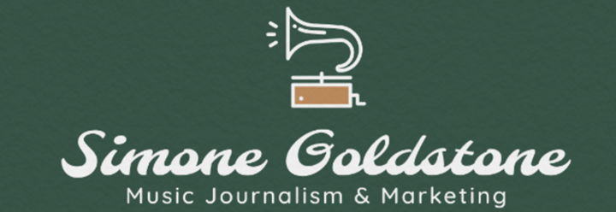
703-376-1240 | www.simonegoldstone.com | simonegoldstonemusic@gmail.com
Reference: Ben Fong-Torres, Rolling Stone Magazine, fongtorres@gmail.com

Soundcheck Columnist, Newport Beach Independent Newspaper, May 2020-Present
- Honored with the Excellence in Journalism Award for Music & Arts by the OC Press Club, competing with LA Weekly and the LA Times
- Increased the publication’s article views and website traffic by over 300%
- Discovered Greer through digital trails before they went on to tour with the Flaming Lips, helped launch their career by establishing PR relationships and writing an article that continues to be their most read
- Collaborated with RS writer David Browne on an article exploring Jeff Buckley’s childhood in Orange County with exclusive stories and interviews with his mother and classmates
- Penned expose on Jefferson Starship that covered never heard anecdotes on Janis Joplin and David Crosby
- Featured on Google News as the first to break the story that John Fogerty's sons’ band Hearty Har had landed a record deal
- Ranked as one of Ben Fong-Torres’ top 3 favorite articles on his documentary, competing with the SF Chronicle, Variety, NBC

Editorial Intern, Merry-Go-Round Magazine
- Originated the blueprint for artist profiles
- Wrote the most popular article on the website, featured as the top search result for Rough Trade Records band Howler for over 4 months
- Established an invaluable relationship with indie label Forged Artifacts, landing them a review in Pitchfork
- Went viral for reviewing Beach Goth 2016
- Wrote the website’s most viewed articles, including a feature on Bob Dylan
- Established writing standards by penning articles used as examples for interns at orientation
- Tracked down sources, used data analytics to find up and coming artists to interview

Intern, Grammy-Award winning producer Cory Rooney, January 2018- January 2019
- Wrote and transcribed all correspondences, emails, and phone calls with producers, record labels, booking agents, and publicists
- Pitched publicity opportunities to publications such as Vogue
- Mitigated meetings with potential new artists
- Organized all budgets for touring, travel, recording, and merchandise
- Drafted contracts for session musicians, transmittal letters, and organized all legal documents
- Assisted with day-to-day responsibilities in the studio and office to ensure smooth recording sessions
- Found potential new artists and researched trends in the music industry

A & R Intern, Riptide Music Group, February 2019- September 2019
- Fulfilled all administrative duties
- Answered phone calls
- Managed and organized VP's calendar
- Filled and scanned paperwork such as recording contracts
- Scheduled artist's travel, flights, lodgings, maintained spreadsheets for travel budgets
- Processed invoices from vendors and kept meticulous track of finances
- Arranged mixing and mastering sessions with studios, artists, and producers

Education: Chapman University: Dodge College of Film & Media Arts, BA Public Relations & Advertising, graduated winter 2019

